SWARNANDHRA COLLEGE OF ENGINEERING AND TECHNOLOGY

**(Autonomous)**

(Approved by A.I.C.T.E & Affiliated to JNTU Kakinada) (Accredited by NAAC with CGPA 3.32/4.00)

Seetharamapuram, Narsapur-534 280

# DEPARTMENT OF COMPUTER SCIENCE AND ENGINEERING

# VOICE ASSISTANT USING PYTHON

A Mini Project Report Submitted in Partial Fulfilment of the Requirement for the Award of the Degree of BACHELOR OF TECHNOLOGY

in

**COMPUTER SCIENCE AND ENGINEERING**

by

1. SIVA DURGA SAI 19A21B0502

K. LOKESH 19A21B0533

Y. DURGA PRASANTH 19A21B0564

##### N. FRANCIS 20A25B0503 Under the Esteemed Guidance

MR. S.UMA MAHESWARAO

Assistant professor

SWARNANDHRA COLLEGE OF ENGINEERING AND TECHNOLOGY

**(AUTONOMOUS)**

(Approved by A.I.C.T.E & Affiliated to JNTU Kakinada) (Accredited by NAAC with CGPA 3.32/4.00)

Seetharamapuram, Narsapur-534 280 DEPARTMENT OF COMPUTER SCIENCE AND ENGINEERING



CERTIFICATE

This is to certify that the Mini Project Report entitled "**VOICE ASSISTANT**”, is being submitted by **A. SIVA DURGA SAI (19A21B0502), K. LOKESH (19A21B0533), Y. DURGA PRASANTH (19A21B0564), N. FRANCIS (20A25B0503)** Of B.Tech VII Semester who carried out the work under my supervision and submitted in partial fulfillment for the award of the degree of "**BACHELOR OF TECHNOLOGY IN COMPUTER SCIENCE AND ENGINEERING**" during the academic year 2021-2022 and it has been found worthy of acceptance according to therequirements of the autonomous.

**Project Guide Head of the Department**

**MR**.**S. UMA MAHESWARAO Dr P. SRINIVASULU**

Associate professor Professor

External Examiner

**ACKNOWLEDGEMENT**

Foremost, we want to offer the endeavor to our GOD Almighty for the wisdom he bestowed upon us, the strength, peace of mind and good health in order to finish this Mini Project.

We would like to express my sincere thanks to our parents for the encouragement for everything. We are hugely indebted to **Dr. S. Suresh Kumar,** Principal for finding out time for us to

share knowledge for being ever so kind to show interest in our work and for giving his precious and kind advice for the same.

We would like to express our grateful thanks to **Dr. P. Srinivasulu**, Professor & Head, Department of Computer Science and Engineering, for his valuable suggestions and guidance regarding the software analysis, Design and also for his continuous effort in the successful completion of the Project.

Our deepest appreciation to the Mini Project Coordinator Mr. **S. UMA MAHESWARAO**, Assoc. Professor, Department of Computer Science and Engineering for his valuable guidance for efficacious completion of the Mini Project.

We would like to express our sincere gratitude and heartfelt thanks to our Mini project guide Mr. **M. Satyanarayana,** for his continuous support, patience, motivation, enthusiasm, and immense knowledge helped us successfully carried out this assignment.

We also place on record, Our thanks to one and all who, directly or indirectly, have lent their helping hand in this venture.

1. SIVA DURGA SAI 19A21B0502

K. LOKESH 19A21B0533 Y. DURGA PRASANTH 19A21B0564

N. FRANCIS 20A25B0503

**DECLARATION**

We certify that

1. The project work contained in the report is original and has been done by under the guidance of my supervisor.
2. The work has not been submitted to any other university for the award of any degree or diploma.
3. The guidelines of the university are followed in writing the report.

Date:

Place:

|  |  |  |
| --- | --- | --- |
| **NAME OF THE STUDENT** | **REG. NO** | **SIGNATURE** |

A.SIVA DURGA SAI 19A21B0502

K. LOKESH 19A21B0533

Y. DURGA PRASANTH 19A21B0564

N. FRANCIS 20A25B0503

### ABSTRACT

Voice assistants are software agents that can interpret human speech and respond via synthesized voices. Apple’s Siri, Amazon’s Alexa, Microsoft’s Cortana, and Google’s Assistant are the most popular voice assistants and are embedded in smartphones or dedicated home speakers.

Users can ask their assistants questions, control home automation devices and media playback via voice, and manage other basic tasks such as email, to-do lists, and calendars with verbal commands. This column will explore the basic workings and common features of today’s voice assistants.

It will also discuss some of the privacy and security issues inherent to voice assistants and some potential future uses for these devices. As voice assistants become more widely used, librarians will want to be familiar with their operation and perhaps consider them as a means to deliver library services and materials.

KEYWORDS:

Human computer interaction Internet

Libraries

Software agents Speech recognition Voice assistant

**Table of Contents**



|  |  |  |
| --- | --- | --- |
| **S. No** | **Title** | **Page No** |
| 1 | Introduction | 1 |
|  | 1.1 Background | 2 4 |
| 1.2 Objectives | 5 |
| 1.3 Purpose, Scope and Applicability |  |
| 2 | Survey of Technology | 6 |
| 3 | Requirement and Analysis | 8 |
|  | 3.1 Problem Definition | 8 9 |
| 3.2 Requirement Specification | 11 |
| 3.3 Software and Hardware Requirement |  |
| 4 | System Design | 12 |
|  | 4.1 ER Diagram | 12 |
| * 1. Activity Diagram   2. Class Diagram   3. Use Case Diagram | 13  14  15  16 |
| 4.5 Sequence Diagram | 18 |
| 4.6 Data Flow Diagram | 21 |
| * 1. Component Diagram   2. Deployment Diagram | 22  23  24 |
| 4.9 Data Dictionary |  |
| 4.10 Test Case Design |  |
|  | Reference and Bibliography | 26 |

# VIRTUAL ASSISTANT

## INTRODUCTION

In today’s era almost all tasks are digitalized. We have Smartphone in hands and it is nothing less than having world at your fingertips. These days we aren’t even using fingers. We just speak of the task and it is done. There exist systems where we can say Text Dad, “I’ll be late today.” And the text is sent. That is the task of a Virtual Assistant. It also supports specialized task such as booking a flight, or finding cheapest book online from various ecommerce sites and then providing an interface to book an order are helping automate search, discovery and online order operations.

Virtual Assistants are software programs that help you ease your day-to-day tasks, such as showing weather report, creating reminders, making shopping lists etc. They can take commands via text (online chat bots) or by voice. Voice based intelligent assistants need an invoking word or wake word to activate the listener, followed by the command. For my project the wake word is JIA. We have so many virtual assistants, such as Apple’s Siri, Amazon’s Alexa and Microsoft’s Cortana. For this project, wake word was chosen JIA.

This system is designed to be used efficiently on desktops. Personal assistant software improves user productivity by managing routine tasks of the user and by providing information from online sources to the user. JIA is effortless to use. Call the wake word ‘JIA’ followed by the command. And within seconds, it gets executed.

Voice searches have dominated over text search. Web searches conducted via mobile devices have only just overtaken those carried out using a computer and the analysts are already predicting that 50% of searches will be via voice by 2020.Virtual assistants are turning out to be smarter than ever. Allow your intelligent assistant to make email work for you. Detect intent, pick out important information, automate processes, and deliver personalized responses.

This project was started on the premise that there is sufficient amount of openly available data and information on the web that can be utilized to build a virtual assistant that has access to making intelligent decisions for routine user activities.

#### BACKGROUND

There already exist a number of desktop virtual assistants. A few examples of current virtual assistants available in market are discussed in this section along with the tasks they can provide and their drawbacks.

SIRI from Apple

SIRI is personal assistant software that interfaces with the user thru voice interface, recognizes commands and acts on them. It learns to adapt to user’s speech and thus improves voice recognition over time. It also tries to converse with the user when it does not identify the user request.

It integrates with calendar, contacts and music library applications on the device and also integrates with GPS and camera on the device. It uses location, temporal, social and task-based contexts, to personalize the agent behavior specifically to the user at a given point of time.

Supported Tasks

* Call someone from my contacts list
* Launch an application on my iPhone
* Send a text message to someone
* Set up a meeting on my calendar for 9am tomorrow
* Set an alarm for 5am tomorrow morning
* Play a specific song in my iTunes library
* Enter a new note

Drawback

SIRI does not maintain a knowledge database of its own and its understanding comes from the information captured in domain models and data models.

ReQall

ReQall is personal assistant software that runs on smartphones running Apple iOS or Google Android operating system. It helps user to recall notes as well as tasks within a location and time context. It records user inputs and converts them into commands, and monitors current stack of user tasks to proactively suggest actions while considering any changes in the environment. It also presents information based on the context of the user, as well as filter information to the user based on its learned understanding of the priority of that information.

Supported Tasks

* Reminders
* Email
* Calendar, Google Calendar
* Outlook
* Evernote
* Facebook, LinkedIn
* News Feeds

Drawback

Will take some time to put all of the to-do items in – you could spend more time putting the entries in than actually doing the revision.

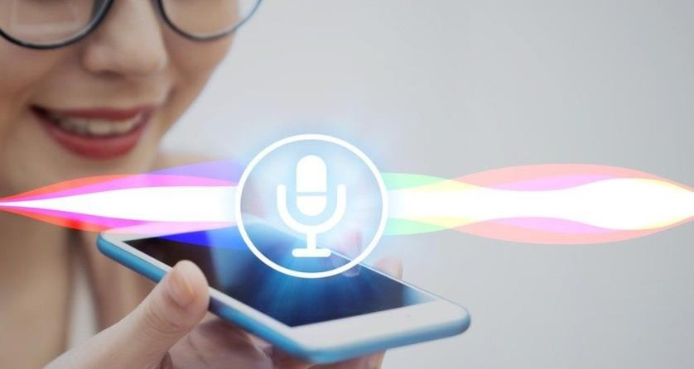

#### OBJECTIVES

Main objective of building personal assistant software (a virtual assistant) is using semantic data sources available on the web, user generated content and providing knowledge from knowledge databases. The main purpose of an intelligent virtual assistant is to answer questions that users may have. This may be done in a business environment, for example, on the business website, with a chat interface. On the mobile platform, the intelligent virtual assistant is available as a call-button operated service where a voice asks the user “What can I do for you?” and then responds to verbal input.

Virtual assistants can tremendously save you time. We spend hours in online research and then making the report in our terms of understanding. JIA can do that for you. Provide a topic for research and continue with your tasks while JIA does the research. Another difficult task is to remember test dates, birthdays or anniversaries. It comes with a surprise when you enter the class and realize it is class test today. Just tell JIA in advance about your tests and she reminds you well in advance so you can prepare for the test.

One of the main advantages of voice searches is their rapidity. In fact, voice is reputed to be four times faster than a written search: whereas we can write about 40 words per minute, we are capable of speaking around 150 during the same period of time15. In this respect, the ability of personal assistants to accurately recognize spoken words is a prerequisite for them to be adopted by consumers.

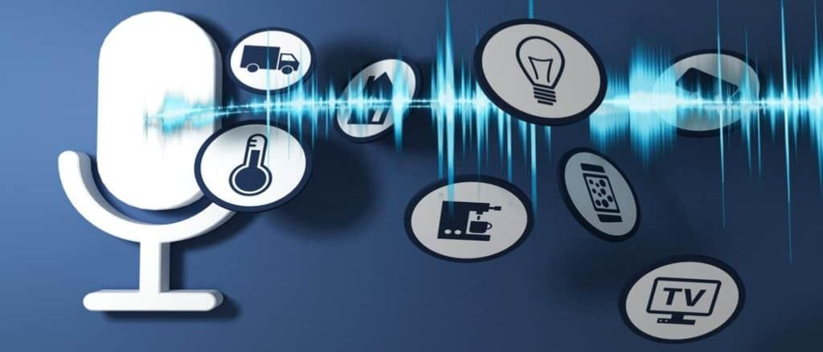

#### PURPOSE, SCOPE AND APPILCABILITY

###### Purpose

Purpose of virtual assistant is to being capable of voice interaction, music playback, making to- do lists, setting alarms, streaming podcasts, playing audiobooks, and providing weather, traffic, sports, and other real-time information, such as news. Virtual assistants enable users to speak natural language voice commands in order to operate the device and its apps.

There is an increased overall awareness and a higher level of comfort demonstrated specifically by millennial consumers. In this ever-evolving digital world where speed, efficiency, and convenience are constantly being optimized, it’s clear that we are moving towards less screen interaction.

###### Scope

Voice assistants will continue to offer more *individualized* experiences as they get better at differentiating between voices. However, it’s not just developers that need to address the complexity of developing for voice as brands also need to understand the capabilities of each device and integration and if it makes sense for their specific brand. They will also need to focus on maintaining a user experience that is consistent within the coming years as complexity becomes more of a concern. This is because the visual interface with voice assistants is missing. Users simply cannot see or touch a voice interface.

###### Applicability

The mass adoption of artificial intelligence in users’ everyday lives is also fueling the shift towards voice. The number of IoT devices such as smart thermostats and speakers are giving voice assistants more utility in a connected user’s life. Smart speakers are the number one way we are seeing voice being used. Many industry experts even predict that nearly every application will integrate voice technology in some way in the next 5 years.

The use of virtual assistants can also enhance the system of IoT (Internet of Things). Twenty years from now, Microsoft and its competitors will be offering personal digital assistants that will offer the services of a full-time employee usually reserved for the rich and famous.

# SURVEY OF TECHNOLOGY

###### Python

Python is an OOPs (Object Oriented Programming) based, high level, interpreted programming language. It is a robust, highly useful language focused on rapid application development (RAD). Python helps in easy writing and execution of codes. Python can implement the same logic with as much as 1/5th code as compared to other OOPs languages.

Python provides a huge list of benefits to all. The usage of Python is such that it cannot be limited to only one activity. Its growing popularity has allowed it to enter into some of the most popular and complex processes like Artificial Intelligence (AI), Machine Learning (ML), natural language processing, data science etc. Python has a lot of libraries for every need of this project. For JIA, libraries used are speech recognition to recognize voice, Pyttsx for text to speech, selenium for web automation etc.

Python is reasonably efficient. Efficiency is usually not a problem for small examples. If your Python code is not efficient enough, a general procedure to improve it is to find out what is taking most the time, and implement just that part more efficiently in some lower-level language. This will result in much less programming and more efficient code (because you will have more time to optimize) than writing everything in a low-level language.

###### DBpedia

Knowledge bases are playing an increasingly important role in enhancing the intelligence of Web and enterprise search and in supporting information integration. The DBpedia leverages this gigantic source of knowledge by extracting structured information from Wikipedia and by making this information accessible on the Web. The DBpedia knowledge base has several advantages over existing knowledge bases: it covers many domains; it represents real community agreement; it automatically evolves as Wikipedia changes, and it is truly multilingual. The DBpedia knowledge base allows you to ask quite surprising queries against Wikipedia for instance “Give me all cities in New Jersey with more than 10,000 inhabitants” or “Give me all Italian musicians from the 18th century”.

###### Quepy

Quepy is a python framework to transform natural language questions to queries in a database query language. It can be easily customized to different kinds of questions in natural language and database queries. So, with little coding you can build your own system for natural language access to your database.

###### Pyttsx

Pyttsx stands for Python Text to Speech. It is a cross-platform Python wrapper for textto-speech synthesis. It is a Python package supporting common text-to-speech engines on Mac OS X, Windows, and Linux. It works for both Python2.x and 3.x versions. Its main advantage is that it works offline.

###### Speech Recognition

This is a library for performing speech recognition, with support for several engines and APIs, online and offline*.* It supports APIs like Google Cloud Speech API, IBM Speech to Text, Microsoft Bing Voice Recognition etc.

SQLite

SQLite is a capable library, providing an in-process relational database for efficient storage of small-to-medium-sized data sets. It supports most of the common features of SQL with few exceptions. Best of all, most Python users do not need to install anything to get started working with SQLite, as the standard library in most distributions ships with the sqlite3 module.

SQLite runs embedded in memory alongside your application, allowing you to easily extend SQLite with your own Python code. SQLite provides quite a few hooks, a reasonable subset of which are implemented by the standard library database driver.

1. **REQUIREMENT AND ANALYSIS**

System Analysis is about complete understanding of existing systems and finding where the existing system fails. The solution is determined to resolve issues in the proposed system. It defines the system. The system is divided into smaller parts. Their functions and inter relation of these modules are studied in system analysis. The complete analysis is followed below.

#### Problem definition

Usually, user needs to manually manage multiple sets of applications to complete one task. For example, a user trying to make a travel plan needs to check for airport codes for nearby airports and then check travel sites for tickets between combinations of airports to reach the destination. There is need of a system that can manage tasks effortlessly.

We already have multiple virtual assistants. But we hardly use it. There are number of people who have issues in voice recognition. These systems can understand English phrases but they fail to recognize in our accent. Our way of pronunciation is way distinct from theirs. Also, they are easy to use on mobile devices than desktop systems. There is need of a virtual assistant that can understand English in Indian accent and work on desktop system.

When a virtual assistant is not able to answer questions accurately, it’s because it lacks the proper context or doesn’t understand the intent of the question. Its ability to answer questions relevantly only happens with rigorous optimization, involving both humans and machine learning. Continuously ensuring solid quality control strategies will also help manage the risk of the virtual assistant learning undesired bad behaviors. They require large amount of information to be fed in order for it to work efficiently.

Virtual assistant should be able to model complex task dependencies and use these models to recommend optimized plans for the user. It needs to be tested for finding optimum paths when a task has multiple sub-tasks and each sub-task can have its own sub-tasks. In such a case there can be multiple solutions to paths, and the it should be able to consider user preferences, other active tasks, priorities in order to recommend a particular plan.

#### REQUIREMENT SPECIFICATION

Personal assistant software is required to act as an interface into the digital world by understanding user requests or commands and then translating into actions or recommendations based on agent’s understanding of the world.

JIA focuses on relieving the user of entering text input and using voice as primary means of user input. Agent then applies voice recognition algorithms to this input and records the input. It then uses this input to call one of the personal information management applications such as task list or calendar to record a new entry or to search about it on search engines like Google, Bing or Yahoo etc. Focus is on capturing the user input through voice, recognizing the input and then executing the tasks if the agent understands the task. Software takes this input in natural language, and so makes it easier for the user to input what he or she desires to be done.

Voice recognition software enables hands free use of the applications, lets users to query or command the agent through voice interface. This helps users to have access to the agent while performing other tasks and thus enhances value of the system itself. JIA also have ubiquitous connectivity through Wi-Fi or LAN connection, enabling distributed applications that can leverage other APIs exposed on the web without a need to store them locally.

Virtual assistants must provide a wide variety of services. These include:

* Providing information such as weather, facts from e.g., Wikipedia etc.
* Set an alarm or make to-do lists and shopping lists.
* Remind you of birthdays and meetings.
* Play music from streaming services such as Saavn and Gaana.
* Play videos, TV shows or movies on televisions, streaming from e.g., Netflix or Hotstar.
* Book tickets for shows, travel and movies.

###### Feasibility Study

Feasibility study can help you determine whether or not you should proceed with your project. It is essential to evaluate cost and benefit. It is essential to evaluate cost and benefit of the proposed system. Five types of feasibility study are taken into consideration.

1. **Technical feasibility:** It includes finding out technologies for the project, both hardware and software. For virtual assistant, user must have microphone to convey their message and a speaker to listen when system speaks. These are very cheap now a days and everyone generally possess them. Besides, system needs internet connection. While using JIA, make sure you have a steady internet connection. It is also not an issue in this era where almost every home or office has Wi-Fi.
2. **Operational feasibility:** It is the ease and simplicity of operation of proposed system. System does not require any special skill set for users to operate it. In fact, it is designed to be used by almost everyone. Kids who still don’t know to write can read out problems for system and get answers.
3. **Economical feasibility:** Here, we find the total cost and benefit of the proposed system over current system. For this project, the main cost is documentation cost. User also would have to pay for microphone and speakers. Again, they are cheap and available. As far as maintenance is concerned, JIA won’t cost too much.
4. **Organizational feasibility:** This shows the management and organizational structure of the project. This project is not built by a team. The management tasks are all to be carried out by a single person. That won’t create any management issues and will increase the feasibility of the project.
5. **Cultural feasibility:** It deals with compatibility of the project with cultural environment. Virtual assistant is built in accordance with the general culture. The project is named JIA so as to represent Indian culture without undermining local beliefs.

This project is technically feasible with no external hardware requirements. Also it is simple in operation and does not cost training or repairs. Overall feasibility study of the project reveals that the goals of the proposed system are achievable. Decision is taken to proceed with the project.

#### HARDWARE AND SOFTWARE REQUIREMENTS

The software is designed to be light-weighted so that it doesn’t be a burden on the machine running it. This system is being build keeping in mind the generally available hardware and software compatibility. Here are the minimum hardware and software requirement for virtual assistant.

###### Hardware:

* Pentium-pro processor or later.
* RAM 512MB or more.

###### Software:

* Windows 7(32-bit) or above.
* Python 2.7 or later
* Chrome Driver
* Selenium Web Automation
* 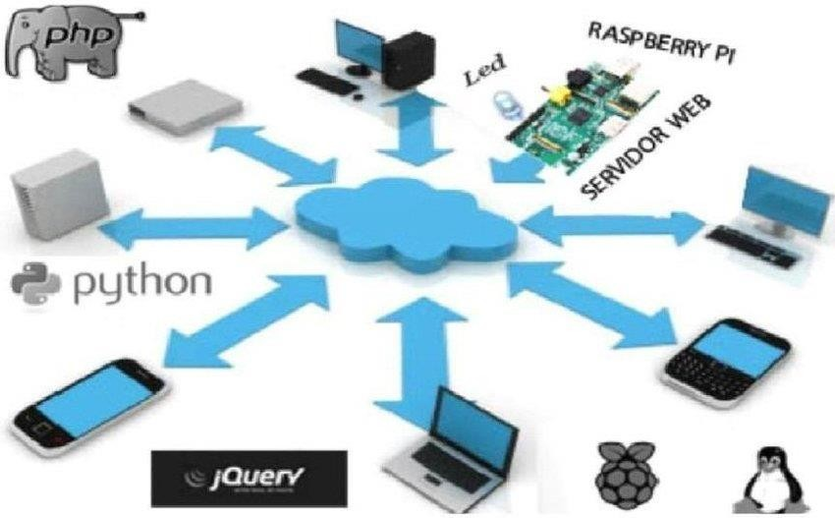SQLite

## SYSTEM DESIGN

#### ER DIAGRAM

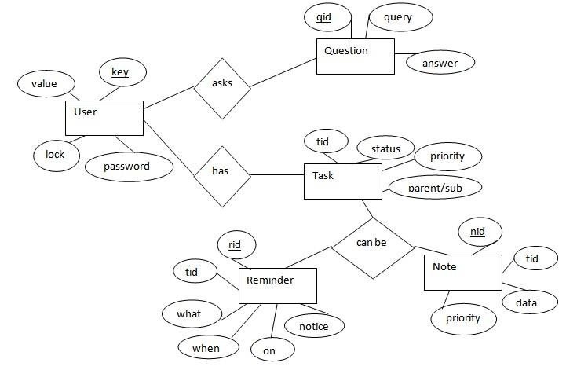

The above diagram shows entities and their relationship for a virtual assistant system. We have a user of a system who can have their keys and values. It can be used to store any information about the user. Say, for key “name” value can be “Jim”. For some keys user might like to keep secure. There he can enable lock and set a password (voice clip).

Single user can ask multiple questions. Each question will be given ID to get recognized along with the query and its corresponding answer. User can also be having n number of tasks. These should have their own unique id and status i.e., their current state. A task should also have a priority value and its category whether it is a parent task or child task of an older task.

#### ACTIVITY DIAGRAM

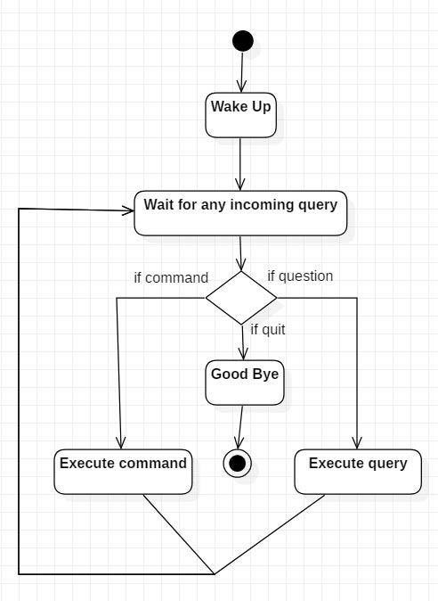

Initially, the system is in idle mode. As it receives any wake up cal it begins execution.

The received command is identified whether it is a questionnaire or a task to be performed. Specific action is taken accordingly. After the Question is being answered or the task is being performed, the system waits for another command. This loop continues unless it receives quit command. At that moment, it goes back to sleep.

#### CLASS DIAGRAM

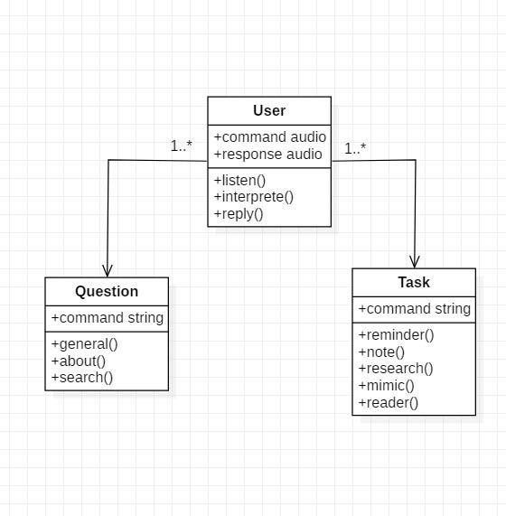

The class user has 2 attributes command that it sends in audio and the response it receives which is also audio. It performs function to listen the user command. Interpret it and then reply or sends back response accordingly. Question class has the command in string form as it is interpreted by interpret class. It sends it to general or about or search function based on its identification.

The task class also has interpreted command in string format. It has various functions like reminder, note, mimic, research and reader.

#### USE CASE DIAGRAM

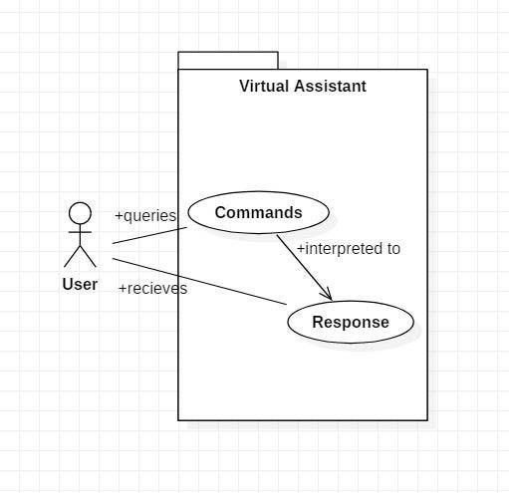

In this project there is only one user. The user queries command to the system. System then interprets it and fetches answer. The response is sent back to the user.

#### SEQUENCE DIAGRAM

* + 1. Sequence diagram for Query-Response

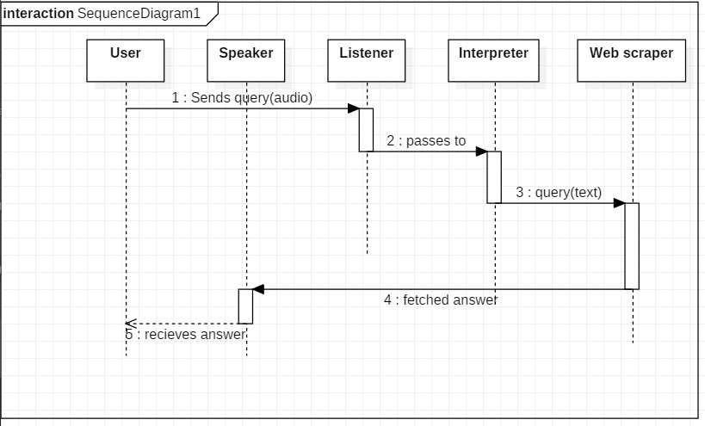

The above sequence diagram shows how an answer asked by the user is being fetched from internet. The audio query is interpreted and sent to Web scraper. The web scraper searches and finds the answer. It is then sent back to speaker, where it speaks the answer to user.

* + 1. Sequence diagram for Task Execution

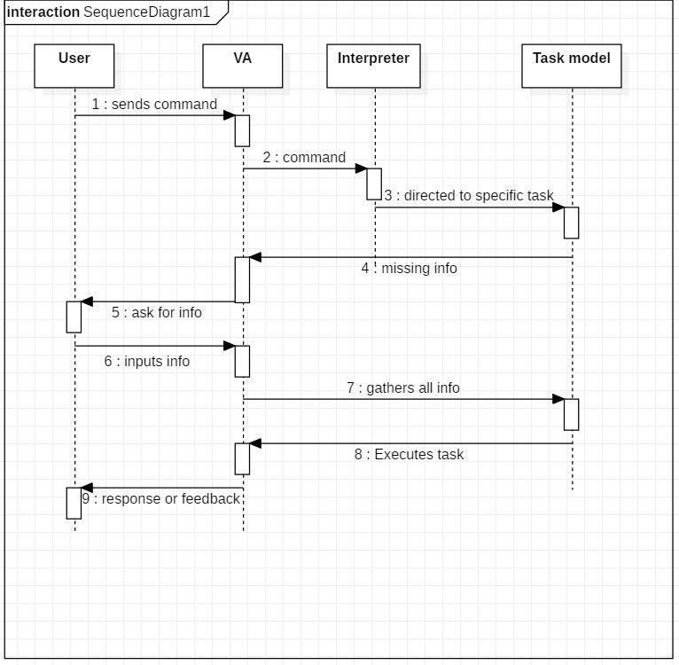

The user sends command to virtual assistant in audio form. The command is passed to the interpreter. It identifies what the user has asked and directs it to task executer. If the task is missing some info, the virtual assistant asks user back about it. The received information is sent back to task and it is accomplished. After execution feedback is sent back to user.

#### DATA FLOW DIAGRAM

* + 1. DFD Level 0 (Context Level Diagram)

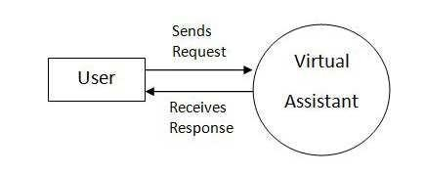

* + 1. DFD Level 1

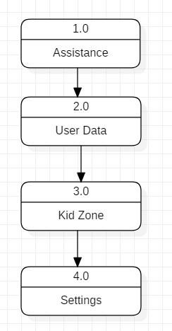

* + 1. 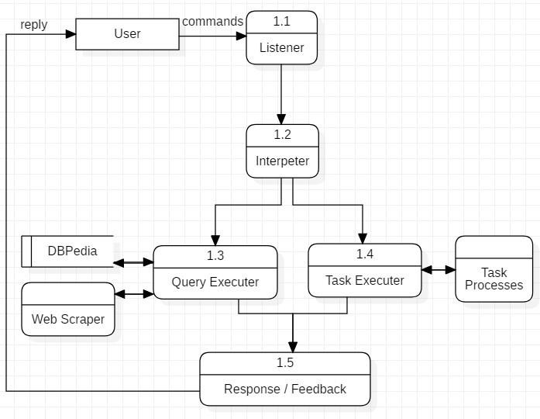DFD Level 2

Data Flow in Assistance

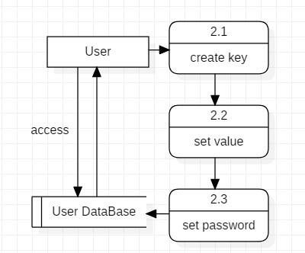

Managing User Data

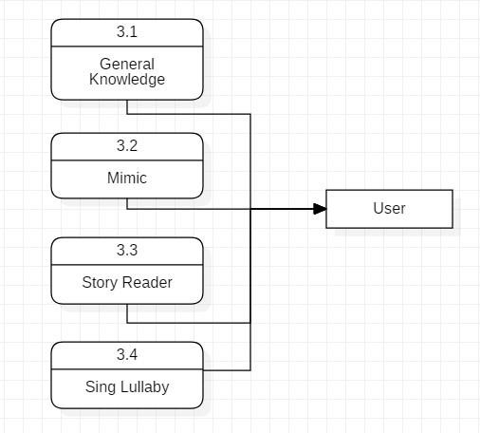

Data Flow in Kid Zone

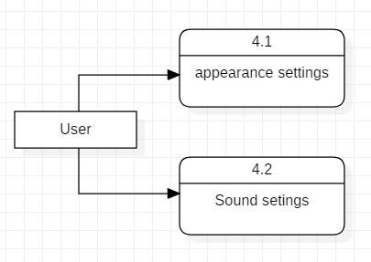

Settings of virtual Assistant

#### COMPONENT DIAGRAM

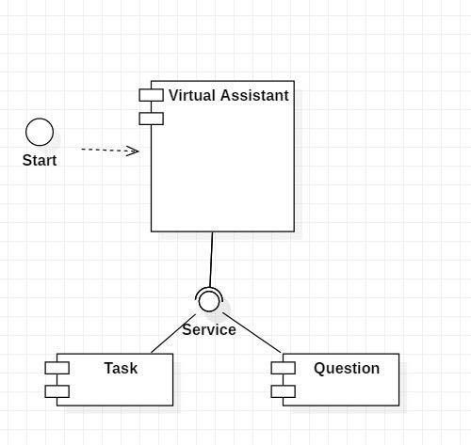

The main component here is the Virtual Assistant. It provides two specific service, executing Task or Answering your question.

#### DEPLOYMENT DIAGRAM

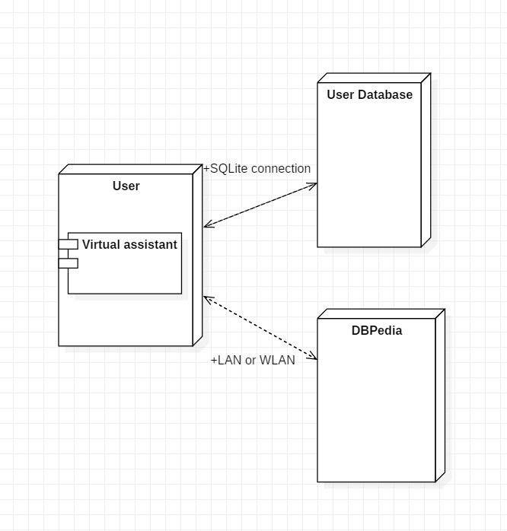

The user interacts with SQLite database using SQLite connection in Python code. The knowledge database DBPedia must be accessed via internet connection. This requires LAN or

WLAN / Ethernet network.

#### DATA DICTIONARY

##### User

|  |  |
| --- | --- |
| Key | Text |
| Value | Text |
| Lock | Boolean |
| Password | Text |

Question

|  |  |
| --- | --- |
| Qid | Integer PRIMARY KEY |
| Query | Text |
| Answer | Text |

##### Task

|  |  |
| --- | --- |
| Tid | Integer PRIMARY KEY |
| Status | Text (Active/Waiting/Stopped) |
| Level | Text (Parent/Sub) |
| Priority | Integer |

Reminder

|  |  |
| --- | --- |
| Rid | Integer PRIMARY KEY |
| Tid | Integer FOREIGN KEY |
| What | Text |
| When | Time |
| On | Date |
| Notify before | Time |

##### Note

|  |  |
| --- | --- |
| Nid | Integer PRIMARY KEY |

|  |  |
| --- | --- |
| Tid | Integer FOREIGN KEY |
| Data | Text |
| Priority | Integer |

PROGRAM FOR VOICE ASSISTANT:

#### import speech_recognition as sr import pyttsx3

**import pywhatkit import datetime import wikipedia import pyjokes**

#### listener = sr.Recognizer() engine = pyttsx3.init()

**voices = engine.getProperty('voices') engine.setProperty('voice', voices[0].id)**

#### def talk(text): engine.say(text) engine.runAndWait()

**def take_command(): try:**

#### with sr.Microphone() as source: print('listening...')

**voice = listener.listen(source)**

#### command = listener.recognize_google(voice) command = command.lower()

**if 'alexa' in command:**

#### command = command.replace('alexa', '')

**print(command) except:**

#### pass

**return command def run_alexa():**

#### command = take_command() print(command)

**if 'play' in command:**

#### song = command.replace('play', '') talk('playing ' + song) pywhatkit.playonyt(song)

**elif 'what is your name ' in command: talk("my name is jarves")**

#### elif 'time' in command:

**time = datetime.datetime.now().strftime('%I:%M %p') talk('Current time is ' + time)**

#### elif 'who is' in command:

**person = command.replace('who is', '') info = wikipedia.summary(person, 1) print(info)**

#### talk(info)

**elif 'date' in command: talk('sorry, I have a headache')**

#### elif 'are you single' in command:

**talk('I am in a relationship with wifi') elif 'joke' in command:**

#### print( talk(pyjokes.get_joke())) elif 'open ' in command:

**talk('open') pywhatkit.search("https://**[**www.google.as/webhp**](http://www.google.as/webhp)**")**

#### else:

**talk('Please say the command again.')**



#### while True: run_alexa()



* + 1. **TEST CASE DESIGN**

###### Test Case 1

**Test Title:** Response Time

Test ID: T1

**Test Priority:** High

**Test Objective:** To make sure that the system respond back time is efficient.

Description:

Time is very critical in a voice based system. As we are not typing inputs, we are speaking them. The system must also reply in a moment. User must get instant response of the query made.

###### Test Case 2

**Test Title:** Accuracy

Test ID: T2

**Test Priority:** High

**Test Objective:** To assure that answers retrieved by system are accurate as per gathered data.

Description:

A virtual assistant system is mainly used to get precise answers to any question asked. Getting answer in a moment is of no use if the answer is not correct. Accuracy is of utmost importance in a virtual assistant system.

###### Test Case 3

**Test Title:** Approximation

Test ID: t3

**Test priority:** Moderate

**Test Objective:** To check approximate answers about calculations.

Description:

There are times when mathematical calculation requires approximate value. For example, if someone asks for value of PI the system must respond with approximate value and not the accurate value. Getting exact value in such cases is undesirable.

Note: There might include a few more test cases and these test cases are also subject to change with the final software development.

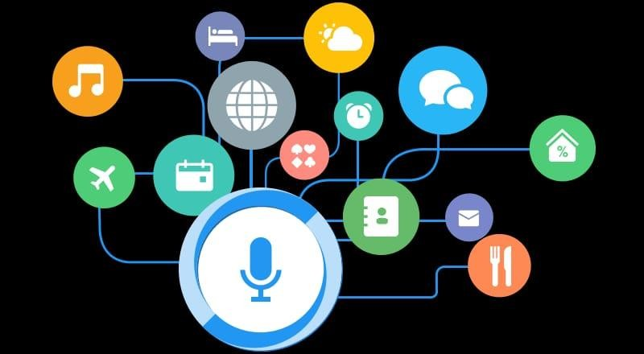

REFERENCE AND BIBLIOGRAPHY

* + Websites referred
    - [www.stackoverflow.com](http://www.stackoverflow.com/)
    - [www.pythonprogramming.net](http://www.pythonprogramming.net/)
    - [www.codecademy.com](http://www.codecademy.com/)
    - [www.tutorialspoint.com](http://www.tutorialspoint.com/)
    - [www.google.co.in](http://www.google.co.in/)

##### Books referred

* + - Python Programming - Kiran Gurbani
    - Learning Python - Mark Lutz

##### YouTube Channels referred

* + - CS Dojo ▪ edureka!

##### Documents referred

* + - Designing Personal Assistant Software for Task Management using Semantic Web Technologies and Knowledge Databases

- Purushotham Botla

* + - Python code for Artificial Intelligence: Foundations of Computational Agents - David L. Poole and Alan K. Mackworth

THANK YOU